**CITY OF BUFFALO REASSESSMENT REFLECTS STRONG ECONOMIC GROWTH WHILE ADVANCING INCLUSIVE TAX POLICIES**

The City of Buffalo’s assessment data collection has demonstrated that economic development benefits every neighborhood in the City. Each of the City’s 75 taxing districts saw an increase in assessed value and the City’s overall taxable assessed value doubled from $6 billion to $12 billion. The City’s robust housing market has been a primary driver of this growth. According to the Buffalo Niagara Realtors Association median home prices have steadily risen:

Several factors drove this increase. The Administration undertook a neighborhood revitalization plan to eliminate dilapidated housing, which demolished over 7,000 uninhabitable residential structures since 2006. Recently, the number of demolitions have fallen, because there are fewer homes that are vacant or beyond rehabilitation. This is a tangible indication of neighborhood rehabilitation and a revitalized interest in home purchases:

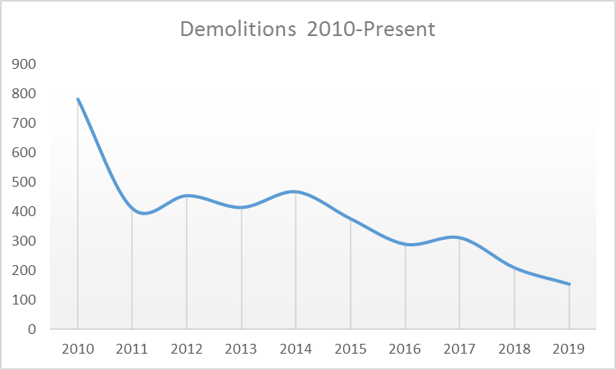

Another key factor has been the number of homes which have been renovated. Increases in renovation permit revenues indicate that a growing number of homeowners are investing in their properties, resulting in increased home values:

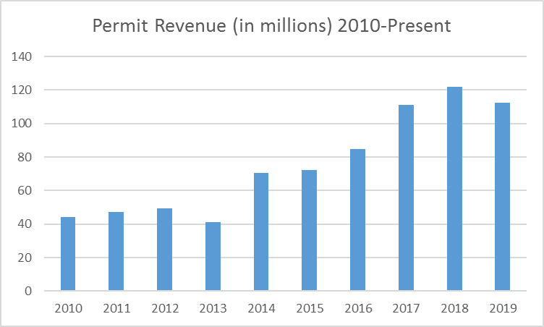

Examples of this practice include:

* A house on Fourteenth Street was a boarded-up and vacant property that sold for $4,000. It was rehabilitated by the new owner and now has an assessed value of $161,000. That is a 4,000% increase in value.
* A house on Seneca Street was sold for $5,172 and was rehabilitated by the new owner. It is now assessed at $150,000 which is a 2,900% increase in value.
* A house on Milnor was bought for $2,500 and was rehabilitated by the new owner. It is now assessed at $63,000 which is a 2,500% increase in value.

These examples, and others, exacerbate the amount by which a neighborhood’s average assessment increases. Removing these outliers from a statistical analysis of average neighborhood assessment increases yields a more accurate illustration of the average increases most homeowners have actually experienced.

Home sales and construction remain stable in the City of Buffalo. According to the most recent (July 2017) “Comprehensive Housing Market Analysis” by the U.S. Department of Housing and Urban Development: “The sales housing market in the HMA is currently balanced. The estimated sales vacancy rate is 1.0 percent, down from 1.3 percent in 2010. During the next three years, demand is estimated for 3,225 homes. The 300 homes under construction and some of the estimated 25,500 other vacant units that may enter the market will satisfy a portion of the demand.”

Since the financial crisis, the number of home sales has become more robust, which contributed to growth in home value assessments. “Hot” housing markets put upward pressure on home values; eventually those markets “cool” and that may lower assessments. Based on the HMA, Buffalo can expect a cyclical cooling of the housing market in the next 2-3 years. The City’s plan to update assessments more frequently in response to the housing market changes will maintain the Administration’s commitment to an equitable assessment of City properties.

A common concern is that the new assessments will automatically mean higher taxes. The following chart demonstrates how 62% of property owners would not see an increase in their taxes based on the current rates even after reassessment.

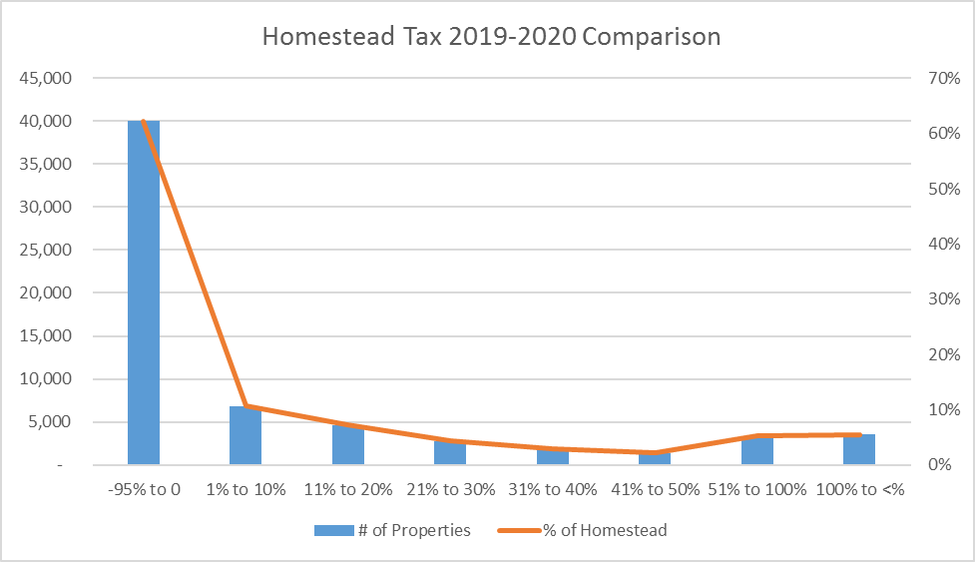



Another concern is that the new assessments will adversely impact seniors and other income-restricted residents. According to the Census Bureau, individuals 65 and over (which is the age of eligibility for the Enhanced STAR exemption) comprise 12% (approximately 32,000) of the City of Buffalo’s population. More than half of these residents live in owner-occupied housing:

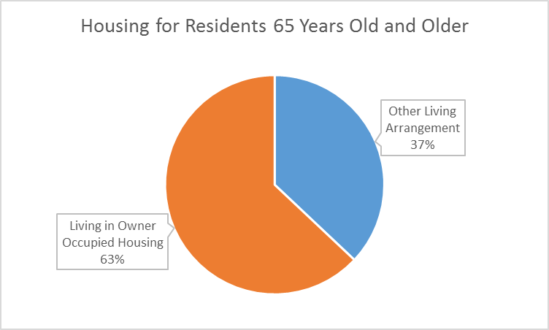

Based on the average household income there are approximately 6,000-7,000 households that are eligible for the Enhanced STAR exemption. The Enhanced STAR exemption is an age and income-based property tax exemption which provides property tax relief to seniors based on their incomes. Today, there are 6,206 households enrolled in the Enhanced STAR program in the City of Buffalo. The City is hosting workshops throughout the City to ensure that all residents who are eligible for the program are enrolled by the December deadline.

Enhanced STAR is just one of 12 different exemption programs that residents can apply for. Below is a breakdown of the number of residents enrolled in each:

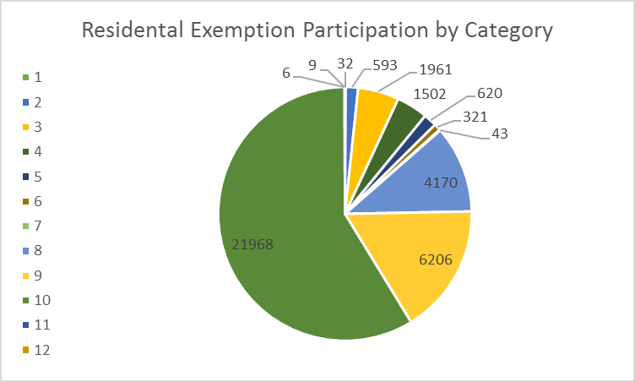

Series 1 Veterans Based on Eligible Funds Series 2 Veterans Pro Rata

Series 3 Veterans War Period Non-Combat Series 4 Veterans War Period Combat

Series 5 Veterans War Period Disability Series 6 Veterans Cold War 15%

Series 7 Veterans Cold War Disabled Series 8 Persons 65 Years of Age and Over

Series 9 Enhanced STAR Series 10 Basic STAR

Series 11 Historic Property Series 12 Home Improvement

There are a total 37,341 property tax exemptions granted in the City of Buffalo. 58% of those exemptions are for households that qualify for the Basic STAR program, which grants an exemption for homeowners whose income is under $250,000 and a credit for those whose income is under $500,000. Between the Basic and Enhanced STAR programs, there are more than 28,000 properties which are eligible for either an exemption or credit on their property taxes.

According to the Buffalo Fiscal Stability Authority’s 2019 analysis on property tax exemptions the residential property taxes outlined above account for approximately 14% (approximately $645 million) of the $4.6 billion in property tax exemptions granted in the City of Buffalo. The largest categories of property tax exemptions are for Governmental purposes (approximately 35%) and Non-Profit/Charitable organizations (approximately 23%). Economic Development exemptions account for approximately 15.5% of the total amount of tax exemptions in the City.

Series 1 Governmental Property

Series 2 Non-Profit/Charitable

Series 3 Residential

Series 4 Economic Development

Series 5 Other

The total number of exemptions for economic development purposes have declined by more than $45 million (approximately 6%) from 2010 to the present. Within the economic development exemptions granted are the 485-a program, which account for $227 million of the total amount of economic development exemptions. The majority of those exemptions will expire between 2024 and 2029.

Series 1 Residential Exemptions

Series 2 485-a Exemptions